- Introduction
This provides a brief description of the GUI concept. This introduction only covers the general appearance and user interaction of the GUI layout. It does not cover any code layout behind the GUI.
- GUI Layout
A QT project was created with a layout of the GUI in QT designer. This is not a complete implementation of the GUI. But it provides a basic concept.

Figure 2.1: Basic GUI Layout
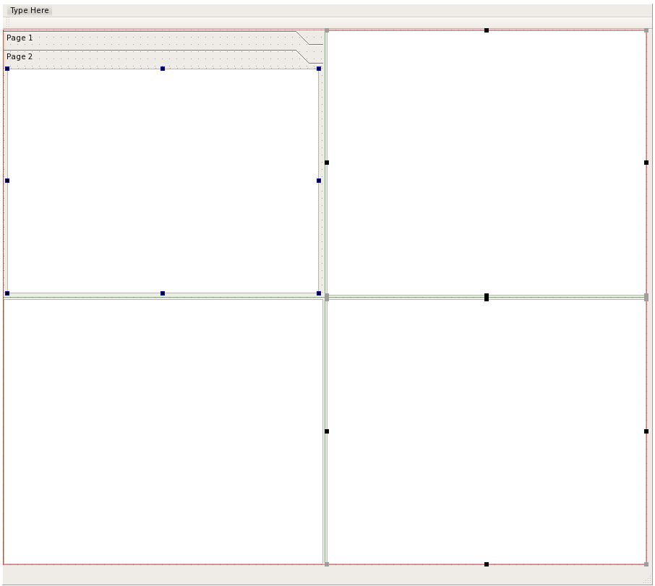
Object Explorer
(Tree View)
Object Properties
(Table View)
Output Messages
(Text View)
Graphical Display
(Graphics View – Not Required)

The basic GUI has four major displayers to it: The object explorer; object properties; output messages; and graphical display. The window should also include scroll bars, a status bar at the bottom of the main windows, and a menu at the top of the main window. Some of these features may not have any functionality associated with them.

- Object Explorer
The object explorer is contained within a set of vertical tabs. The GUI would theoretically be able to open multiple oFreq projects at a time. The object tree for each project would be displayed in its own tab. The object explorer provides an object tree arrangement. It shows all the major input objects associated with oFreq. When the user right clicks on the object, it brings up a context sensitive menu of object methods. When the user left clicks on the object, the object properties window updates to show all properties for that object.
- Object Properties
The object properties window is a table display window, showing the properties for each input object. When the user clicks on an object in the object explorer, the properties for that object are displayed in the object properties window.
Basic table layout would be three columns: property name, property value, and units. The explorer may also contain a small section at the bottom of its window to provide a brief description for each object property.
- Output Messages
The output messages window provides feedback to the user. It displays any error messages. It provides updates on the status of a long run. It provides confirmation of successfully completing any object methods. This should be a window with a scroll bar to allow the user to review past messages.
- Graphical Display
The graphical display is currently beyond the scope of this project. It will provide a 3D visualization of the bodies currently used by the oFreq run. This requires knowledge of the body mesh, which is currently not defined in a format suitable for oFreq.
- Conclusion
That completes the layout description for the GUI. This is a very basic description and will expand with further iterations.

